Q-13. Write an SQL query to show only odd rows from a table.

Ans:

SELECT *

FROM worker

WHERE MOD(worker_id,2)=1;

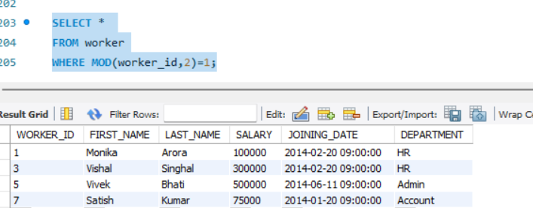

#### Q-14. Write an SQL query to clone a new table from another table.

#### Ans:

#### CREATE TABLE worker_new SELECT * FROM worker;

#### SELECT * FROM worker_new;

#### 